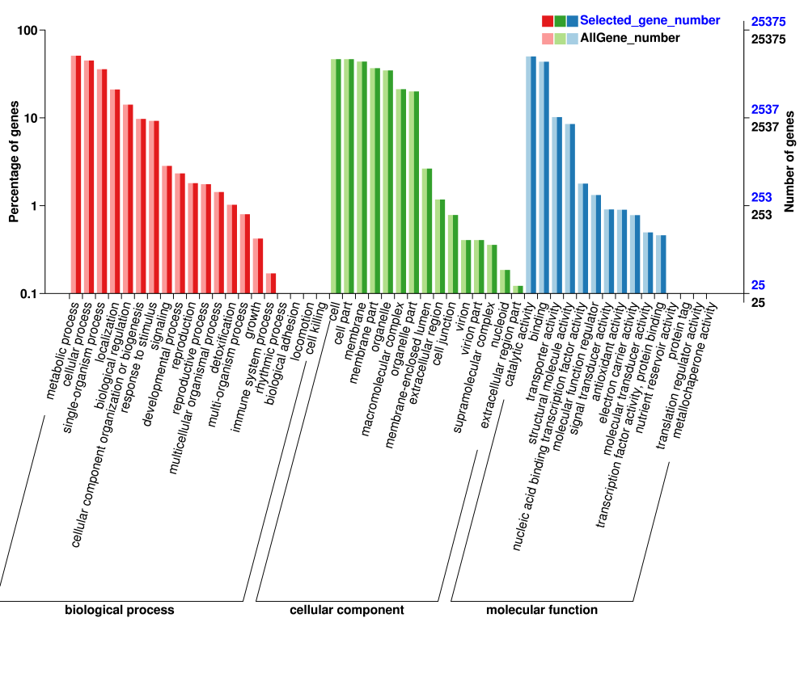
File.S3 Histogram of GO classification of assembled unigenes

